Sqoop

1) Ejercicio 1: Sqoop help, tools e interacción con BBDD

> sqoop-list-databases --connect jdbc:mysql://localhost/employees

> sqoop-list-tables --connect jdbc:mysql://localhost/employees

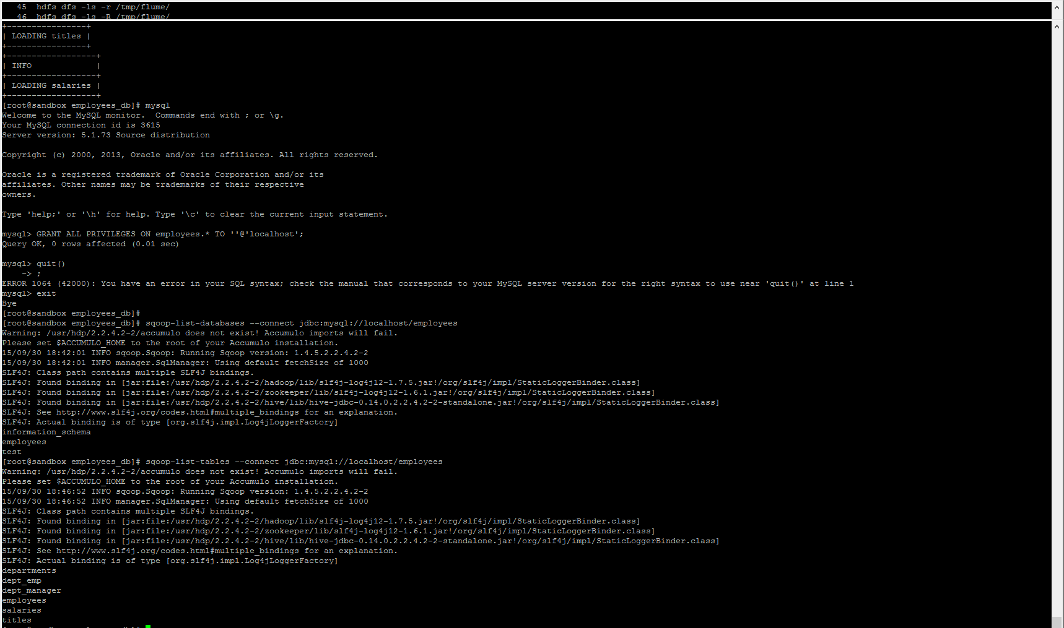

2) Ejercicio 2: Importaciones básicas

> sqoop-import --connect jdbc:mysql://localhost/employees -table employees -m 1

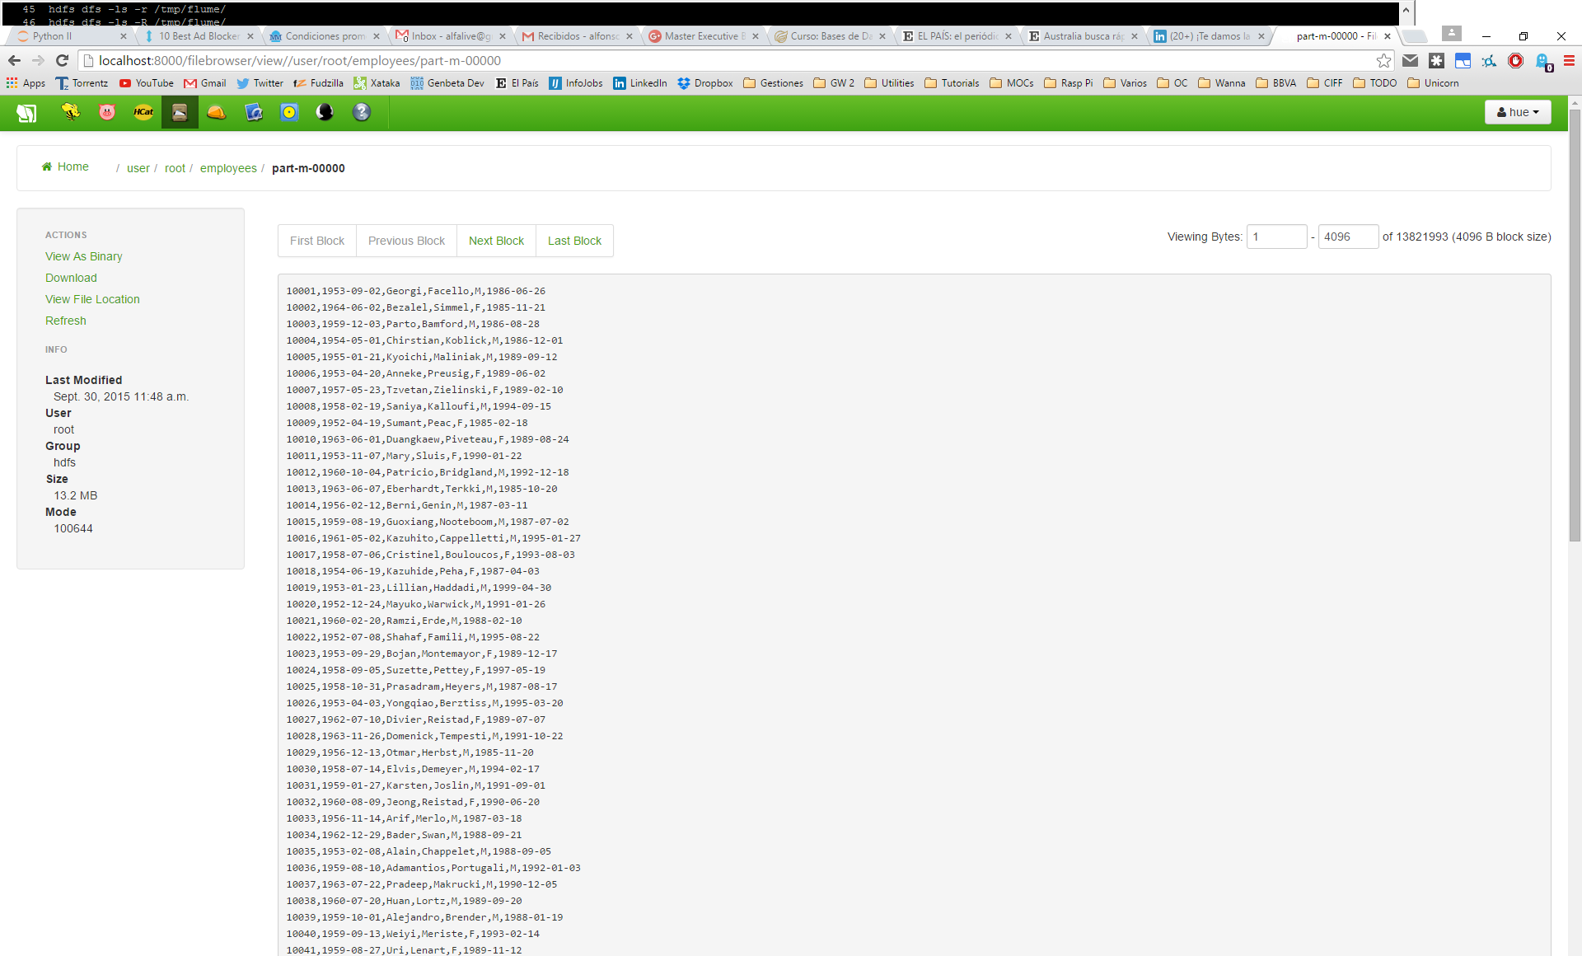

> sqoop-import --connect jdbc:mysql://localhost/employees -table employees -m 2 --target-dir /sqoop/full_table --fields-terminated-by '\t'

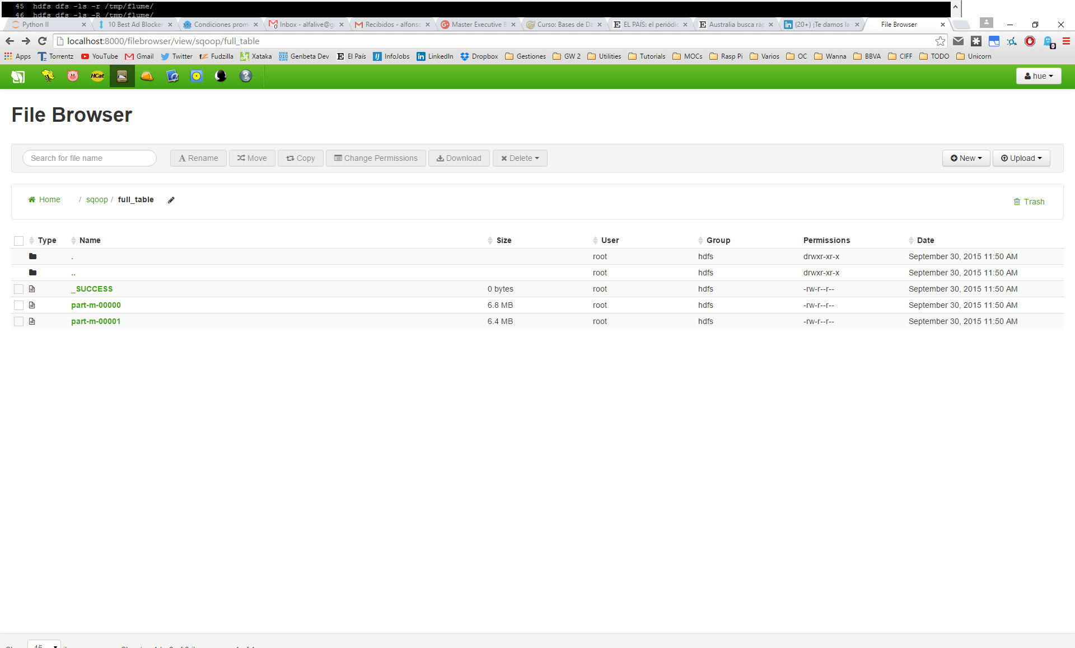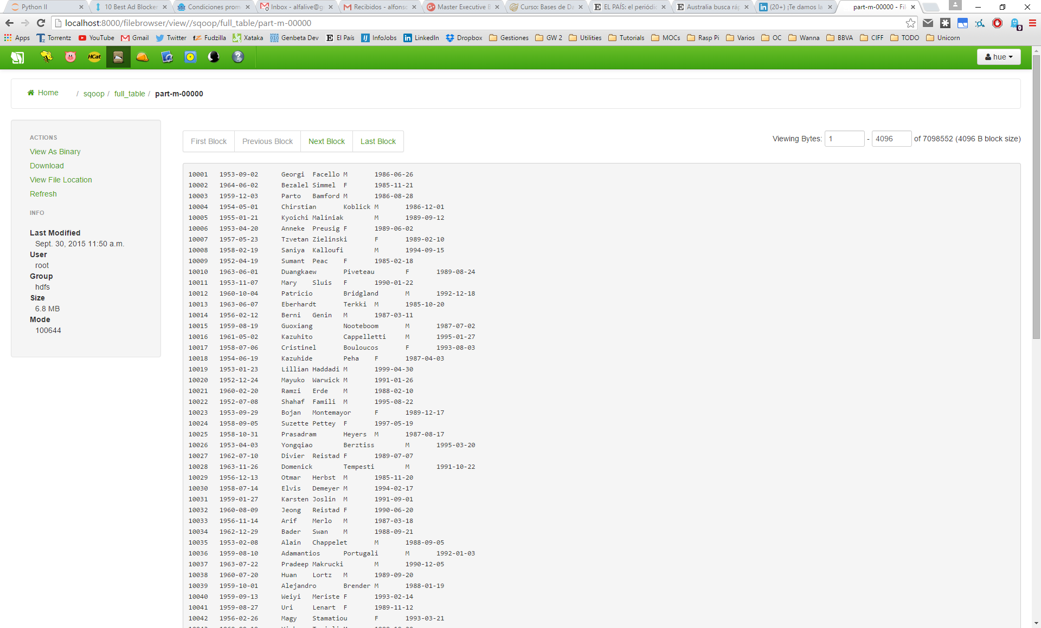

3) Ejercicio 3: Filtrando columnas y filas

> sqoop-import --connect jdbc:mysql://localhost/employees -table employees -m 2 --target-dir /sqoop/some_columns --fields-terminated-by '\t' --columns first_name,last_name

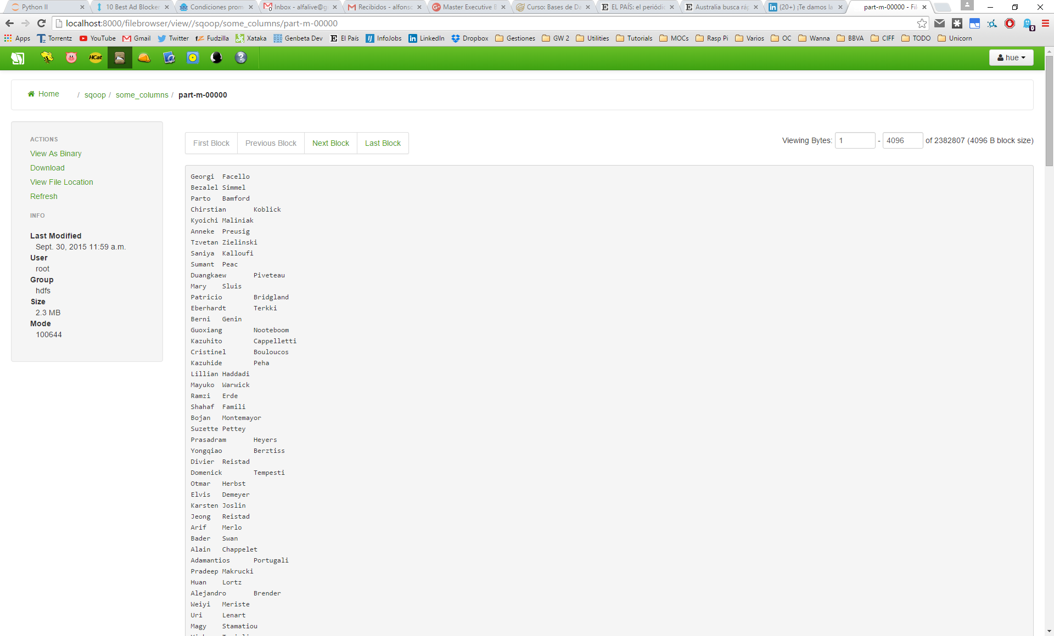

> sqoop-import --connect jdbc:mysql://localhost/employees -table employees -m 2 --target-dir /sqoop/recent_employees --fields-terminated-by '\t' --where "emp_no > 499948"

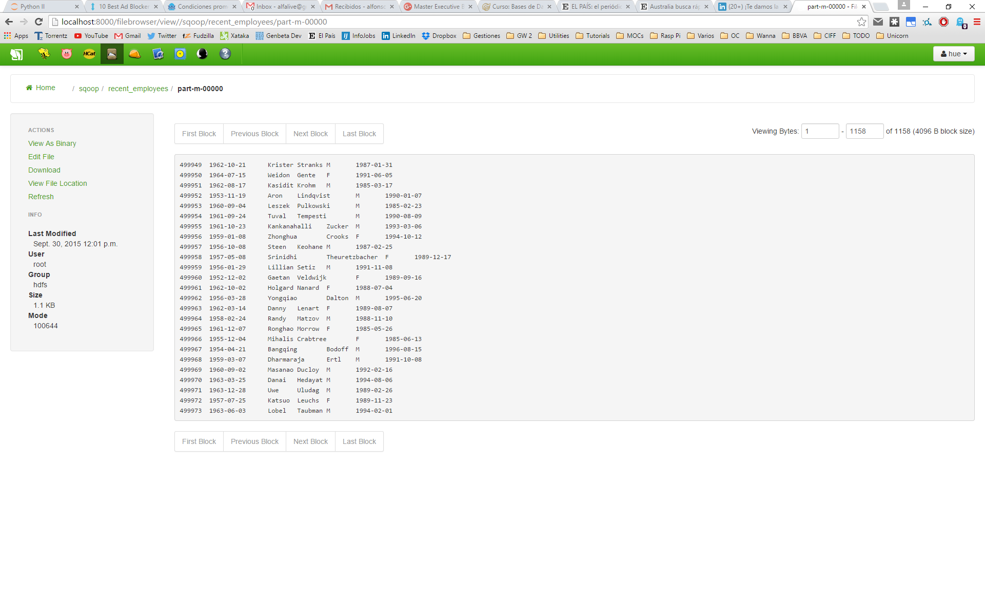

4) Ejercicio 4: Importación a Hive

> sqoop import-all-tables --connect jdbc:mysql://localhost/employees --hive-import

